Activation Functions in Neural Networks

1.Introduction
An activation function is a mathematical function applied to the weighted sum of inputs in an artificial neuron. It determines how strongly a neuron should respond and introduces non-linearity into a neural network. Without a non-linear activation function, multiple neural-network layers would behave essentially like a single linear transformation, which would severely restrict the ability to model complex biological relationships.
In biotechnology and life-science data analysis, neural networks are used for DNA/RNA sequence classification, protein structure and function prediction, microscopy and image analysis, disease classification, biomarker prediction, omics-data analysis, fermentation/process monitoring, and molecular-property prediction. The choice of activation function affects gradient flow, convergence, stability, and the type of output produced.

2. Basic Working of an Artificial Neuron
For inputs x₁, x₂, …, xₙ, weights w₁, w₂, …, wₙ and bias b:
z = Σ(wᵢxᵢ) + b and y = f(z)
Here, z is the pre-activation value, f(·) is the activation function, and y is the neuron output. In a biological analogy, z can be viewed as an integrated input signal, while f(z) represents a simplified mathematical response of the computational unit. This is only an analogy: artificial neurons are not literal biological neurons.

3. Major Types of Activation Functions
Activation function | Formula | Output range | Common role
Binary Step | f(x)=1 if x≥0; otherwise 0 | {0,1} | Historical threshold neuron
Linear | f(x)=x | (-∞,∞) | Regression/output layers
Sigmoid | 1/(1+e⁻ˣ) | (0,1) | Binary probability/output
Tanh | tanh(x) | (-1,1) | Centered hidden activations
ReLU | max(0,x) | [0,∞) | Common hidden layers
Leaky ReLU | max(αx,x), α≈0.01 | (-∞,∞) | Hidden layers; reduce dead neurons
ELU | x if x>0; α(eˣ−1) if x≤0 | (-α,∞) | Hidden layers
Softplus | ln(1+eˣ) | (0,∞) | Smooth ReLU alternative
Swish | x·sigmoid(x) | ≈(-0.28,∞) | Deep hidden layers
GELU | xΦ(x) | ≈(-0.17,∞) | Modern deep networks/transformers
Softmax | eᶻⁱ / Σⱼeᶻʲ | Each in (0,1); sum=1 | Multi-class output

3.1 Binary Step / Threshold
Formula: f(x) = 1, if x ≥ 0; f(x) = 0, if x < 0
Range: {0,1}
The binary step function produces a hard decision. It was important in early threshold-based neuron models, but it is rarely used for training modern neural networks.
Advantages:
- Simple and computationally inexpensive.
- Direct yes/no decision.
Limitations:
- Not differentiable at x=0.
- Derivative is zero almost everywhere, so gradient-based learning is ineffective.
Biotechnology applications:
- Historical neural-network models; simple threshold classification concepts in educational demonstrations.

3.2 Linear
Formula: f(x) = x
Range: (-∞, ∞)
The linear function passes the input directly to the output. It is useful when the target is continuous, such as predicting a numerical biological measurement.
Advantages:
- Very simple; derivative is constant.
- Suitable for unrestricted continuous regression outputs.8
Limitations:
- Provides no non-linearity.
- If used in every hidden layer, a deep network collapses to an equivalent linear transformation.
Biotechnology applications:
- Prediction of continuous variables such as concentration, yield, growth rate, or a quantitative phenotype.

3.3 Sigmoid
Formula: σ(x) = 1/(1 + e⁻ˣ)
Range: (0,1)
Sigmoid compresses any real-valued input into a value between 0 and 1. It is naturally interpreted as a probability when used in a binary-classification output layer.
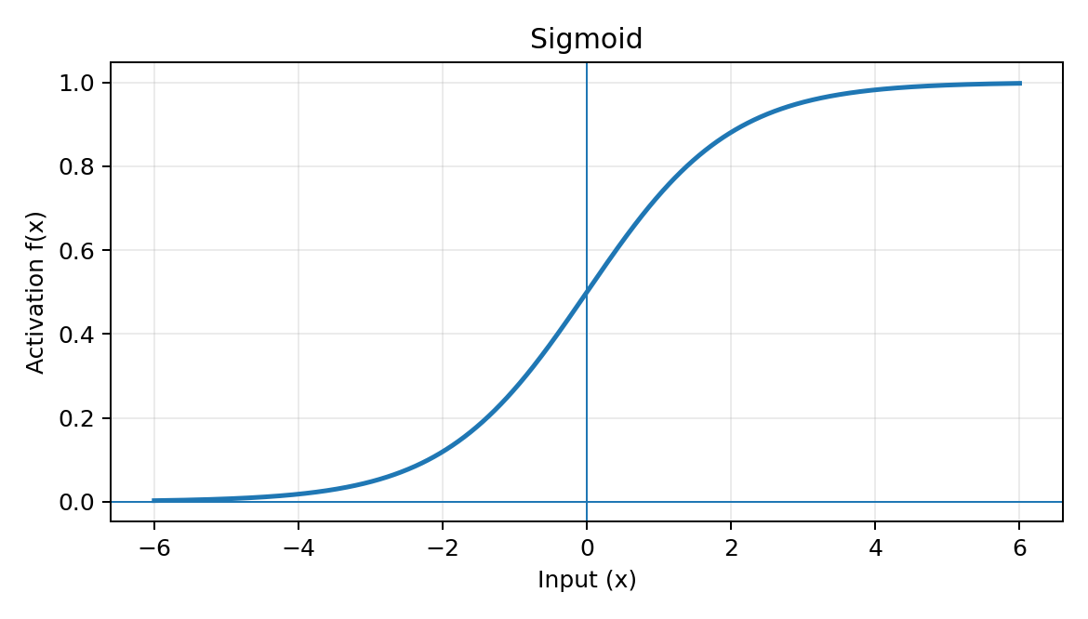
Advantages:
- Smooth and differentiable.
- Useful for binary classification probabilities.
- Output has an intuitive probabilistic interpretation.
Limitations:
- Saturates for large positive or negative inputs, producing small gradients.
- Not zero-centered.
- Can lead to slow learning in deep hidden layers.
Biotechnology applications:
- Binary disease classification, presence/absence of a biomarker, binary phenotype prediction, and yes/no classification of sequence features.

3.4 Hyperbolic Tangent (Tanh)
Formula: tanh(x) = (eˣ − e⁻ˣ)/(eˣ + e⁻ˣ)
Range: (-1,1)
Tanh is a zero-centered S-shaped function. Compared with sigmoid, it produces both positive and negative activations and is often better suited to hidden representations when saturation is not dominant.
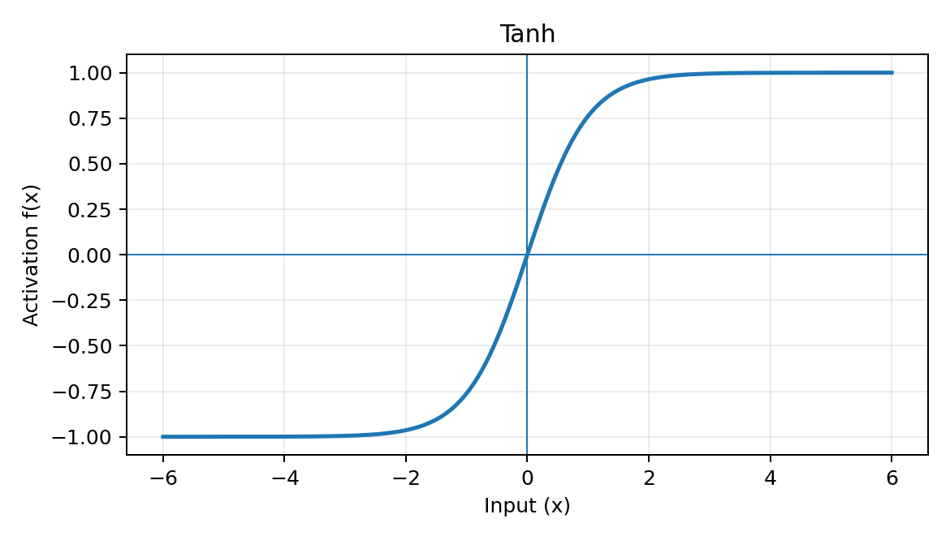
Advantages:
- Zero-centered output.
- Stronger gradients around zero than sigmoid.
- Useful for modeling signed or bidirectional patterns.
Limitations:
- Saturates at both ends.
- Can still suffer from vanishing gradients in deep networks.
Biotechnology applications:
- Sequence modeling, time-series biological signals, recurrent networks, and representation learning where signed activations are useful.

3.5 ReLU (Rectified Linear Unit)
Formula: f(x) = max(0,x)
Range: [0,∞)
ReLU outputs zero for negative inputs and behaves linearly for positive inputs. It became a standard hidden-layer activation because it is simple and usually provides better gradient flow than sigmoid or tanh on the positive side.
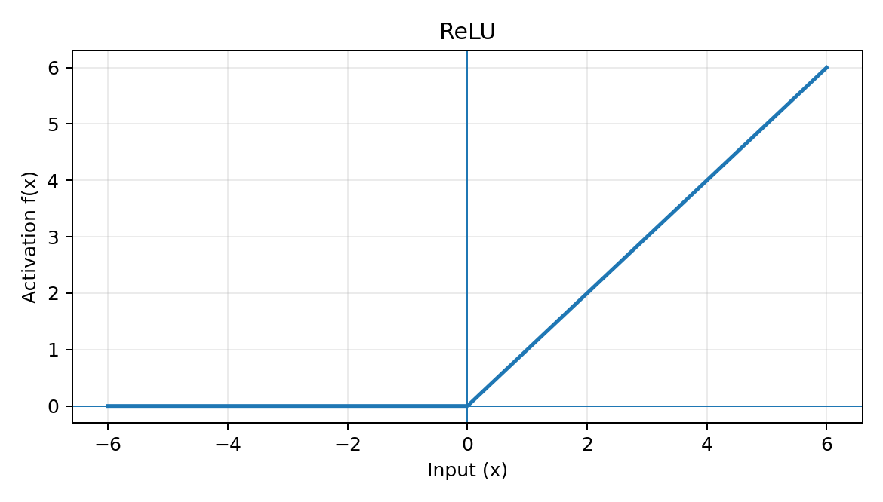
Advantages:
- Computationally simple.
- Does not saturate for positive inputs.
- Encourages sparse activations because negative inputs become zero.
- Often gives fast optimization in deep networks.
Limitations:
- Dead-ReLU problem: a neuron can become stuck outputting zero if it receives persistently negative inputs.
- Not differentiable exactly at zero, although a subgradient is used in practice.
Biotechnology applications:
- CNN-based microscopy/image classification, DNA/RNA sequence models, protein prediction, omics classification, and deep feature extraction.

Leaky ReLU
Formula: f(x) = x, if x>0; αx, if x≤0, typically α≈0.01
Range: (-∞,∞)
Leaky ReLU keeps a small non-zero slope for negative inputs. This allows some gradient to pass through neurons that would be completely inactive under ordinary ReLU.
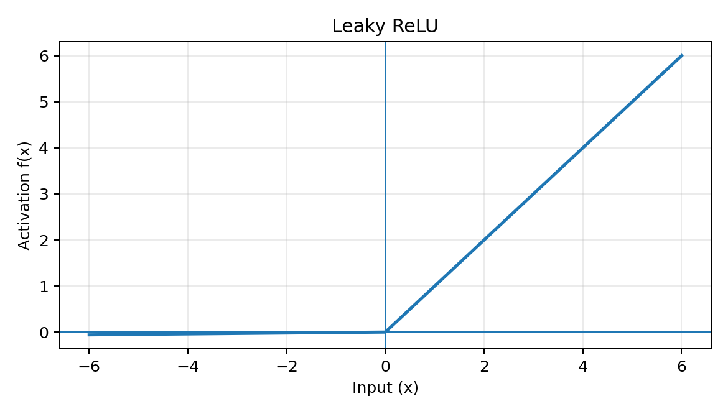
Advantages:
- Reduces the dead-ReLU problem.
- Simple and computationally efficient.
- Maintains gradient flow on the negative side.
Limitations:
- The negative slope α is an additional hyperparameter.
- Negative outputs can be less intuitive for some architectures.
Biotechnology applications:
- Deep biological-image models, sequence classification, and omics prediction when ReLU units show excessive inactivity.

ELU (Exponential Linear Unit)
Formula: f(x) = x, if x>0; α(eˣ−1), if x≤0
Range: (-α,∞)
ELU is linear for positive inputs and smoothly approaches −α for negative inputs. It combines ReLU-like positive behavior with negative outputs and a smooth negative branch.
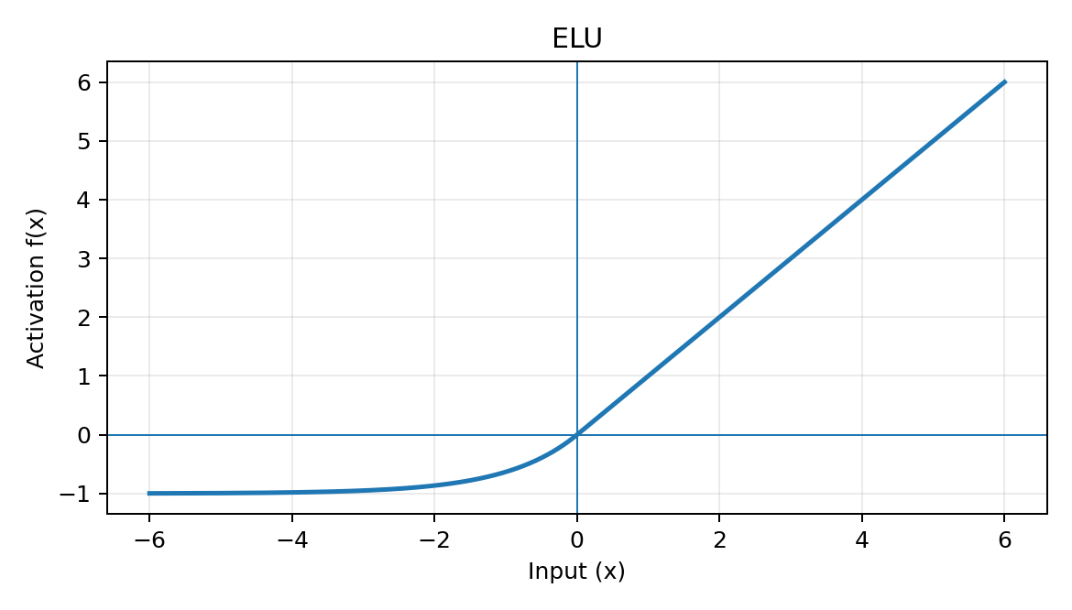
Advantages:
- Negative outputs can keep activations closer to zero-centered.
- Smooth negative branch.
- Can improve optimization in some networks.
Limitations:
- More computationally expensive than ReLU because of the exponential.
- Requires selection of α.
Biotechnology applications:
- Biological image classification, omics prediction, and deep regression/classification models where smoother negative activations are beneficial.

Softplus
Formula: f(x) = ln(1 + eˣ)
Range: (0,∞)
Softplus is a smooth approximation to ReLU. It never becomes exactly zero and has a continuously varying slope.
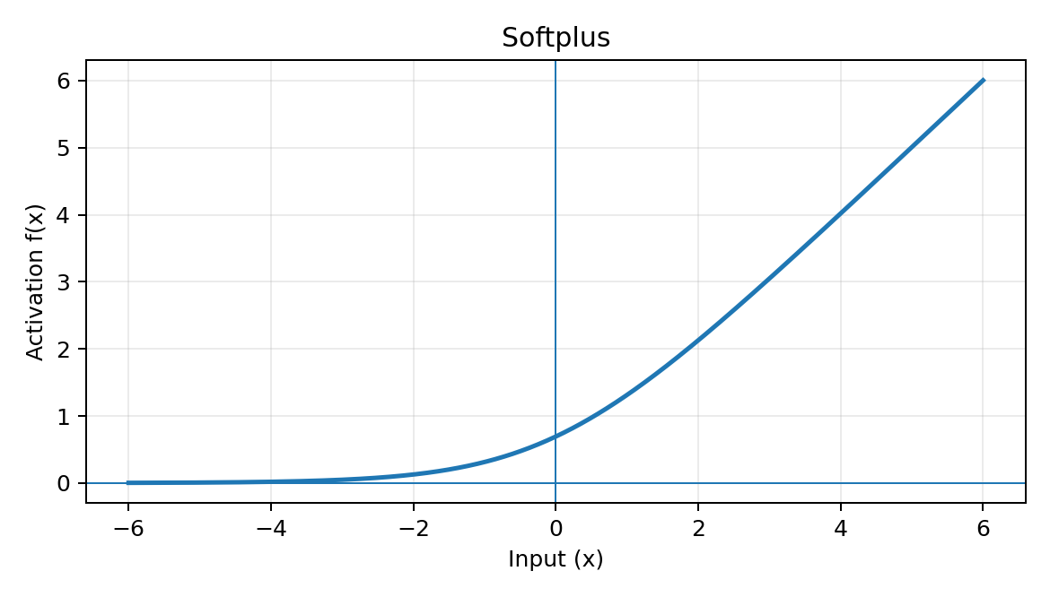
Advantages:
- Smooth and differentiable.
- Avoids the hard zero region of ReLU.
- Useful when smooth optimization is desired.
Limitations:
- More computationally expensive than ReLU.
- Often less sparse than ReLU.
- Can learn more slowly than ReLU in some architectures.
Biotechnology applications:
- Smooth regression models, probabilistic neural networks, and biological-property prediction where a positive continuous output is useful.

Swish
Formula: f(x) = x·σ(x)
Range: Approximately (-0.28,∞)
Swish is a smooth, non-monotonic activation. Unlike ReLU, it can produce small negative outputs, which may help information flow through deep networks.
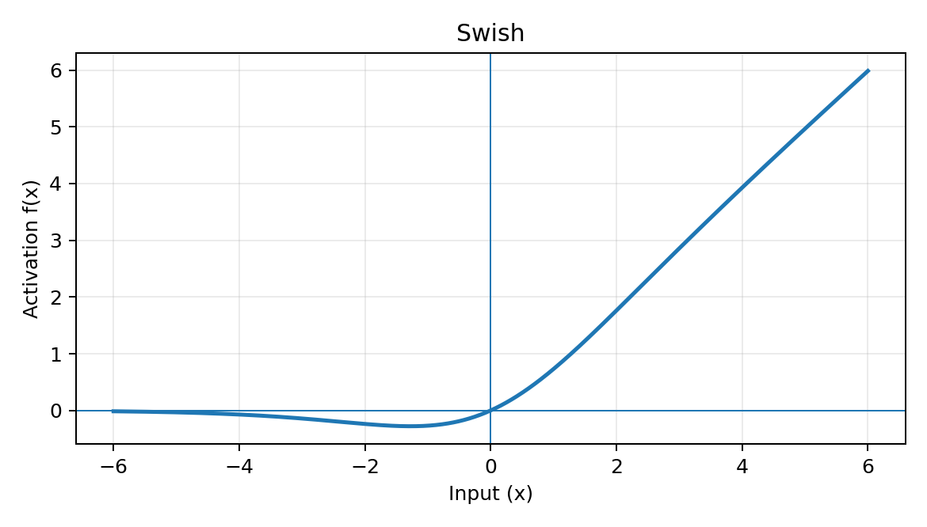
Advantages:
- Smooth and differentiable.
- Non-monotonic behavior can improve representation flexibility.
- Often competitive with or better than ReLU in some deep architectures.
Limitations:
- More computationally expensive than ReLU.
- Performance depends on architecture and task.
Biotechnology applications:
- Deep learning for microscopy, genomics, protein-related prediction, and other complex biological feature-learning tasks.

GELU (Gaussian Error Linear Unit)
Formula: GELU(x) = xΦ(x), where Φ(x) is the standard normal CDF
Range: Approximately (-0.17,∞)
GELU weights inputs according to their magnitude rather than applying a strict zero/non-zero threshold. It is widely associated with modern transformer-based architectures.
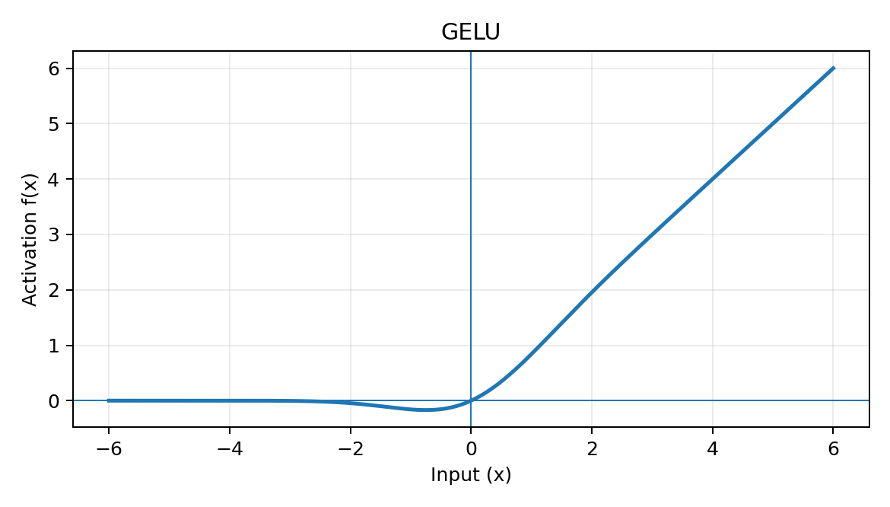
Advantages:
- Smooth.
- Provides probabilistic-style gating of inputs.
- Works well in many modern deep architectures.
Limitations:
- More computationally involved than ReLU.
- Its benefit is architecture- and dataset-dependent.
Biotechnology applications:
- Transformer-based analysis of biological sequences, protein language models, genomic language models, and multimodal biomedical models.

Softmax
Formula: softmax(zᵢ) = eᶻⁱ / Σⱼeᶻʲ
Range: Each output is (0,1); Σ probabilities = 1
Softmax converts a vector of class scores (logits) into a probability distribution across mutually exclusive classes. It is normally used in the final layer of multi-class classifiers rather than as a general hidden-layer activation.
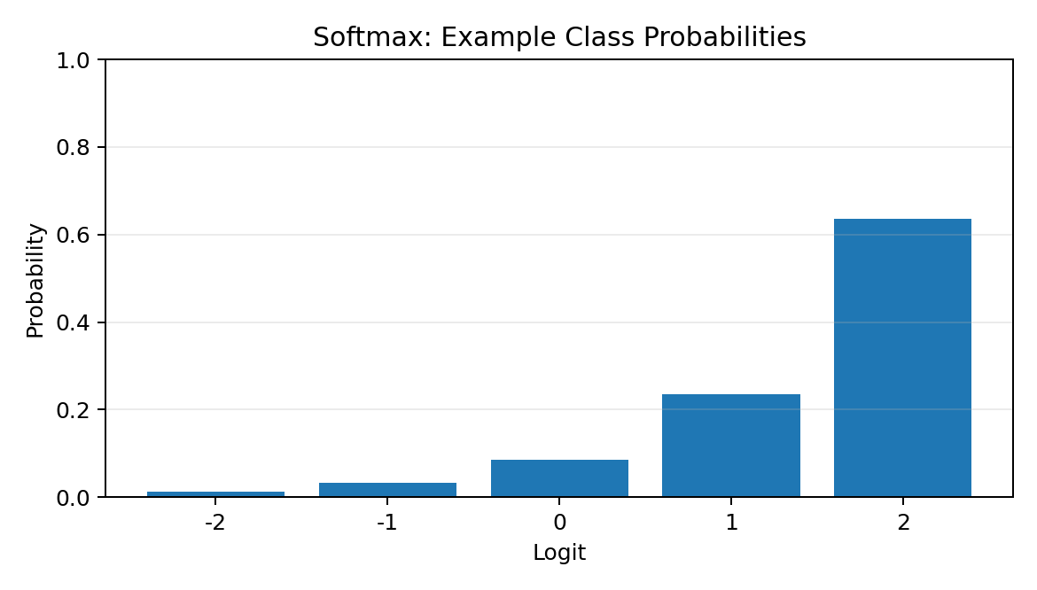
Advantages:
- Produces normalized class probabilities.
- Useful for multi-class classification.
- Differentiable and compatible with cross-entropy loss.
Limitations:
- Can become numerically unstable if implemented naively; stable implementations subtract the maximum logit.
- Not appropriate when classes are not mutually exclusive; sigmoid-based outputs are generally used for multi-label classification.
Biotechnology applications:
- Classification of cell types, microbial species, tissue classes, protein families, disease categories, and other mutually exclusive biological classes.

Why Activation Functions Matter in Biotechnology
- Biological datasets are usually non-linear: relationships between genes, proteins, metabolites, environmental variables, and phenotypes rarely follow a simple linear rule.
- Sequence data contain local and long-range dependencies. Non-linear activations allow CNNs, RNNs, and transformer architectures to construct increasingly complex representations.
- Microscopy images contain complex spatial patterns such as cell morphology and subcellular structures. ReLU-family and modern smooth activations are commonly useful in deep image models.
- Omics datasets can be high-dimensional and noisy. Activation choice influences gradient flow and therefore the ability of the model to learn useful features.
- Output activation should match the prediction problem: linear for unrestricted continuous regression, sigmoid for binary/multi-label probability outputs, and softmax for mutually exclusive multi-class outputs.

Comparison of Common Activation Functions
Function | Gradient behavior | Main strength | Main limitation | Typical layer
Sigmoid | Can vanish at extremes | Probability output | Vanishing gradient | Binary output
Tanh | Can vanish at extremes | Zero-centered | Vanishing gradient | Some hidden/recurrent layers
ReLU | 1 for x>0; 0 for x<0 | Fast, simple | Dead neurons | Hidden layers
Leaky ReLU | 1 positive; α negative | Keeps negative gradient | α must be chosen | Hidden layers
ELU | Smooth negative branch | Negative outputs + smoothness | Exponential cost | Hidden layers
Softplus | Sigmoid derivative | Smooth ReLU-like behavior | Less sparse, slower | Hidden/regression
Swish | Smooth, non-monotonic | Flexible deep representations | More computation | Hidden layers
GELU | Smooth gating | Strong modern deep-learning performance | More computation | Transformers/deep models
Softmax | Coupled class probabilities | Multi-class probability distribution | Only for exclusive classes | Multi-class output

Selection Guide for a Biotechnologist
Binary classification: Sigmoid output is a standard choice when a single probability is required.
Multi-class classification: Softmax output is appropriate when each sample belongs to one of several mutually exclusive classes.
Multi-label classification: Use independent sigmoid outputs when multiple biological labels can be true simultaneously.
Continuous prediction: A linear output is common when the target can take unrestricted real values.
Deep hidden layers: ReLU, Leaky ReLU, GELU, Swish, or related functions are common choices; the best choice depends on architecture and data.
Sequence models: Tanh may still be useful in recurrent structures, while GELU/Swish are common in modern deep sequence architectures.
Biological image analysis: ReLU-family or modern smooth activations are frequently used in CNNs and vision transformers.

Key Conclusion
Activation functions are fundamental components of neural networks because they introduce non-linearity and determine how information is transformed between layers. For biotechnology applications, there is no universally best activation function. ReLU and its variants are strong general-purpose choices for hidden layers; sigmoid and softmax are especially important for probabilistic classification outputs; linear activation is commonly used for continuous regression; and GELU or Swish can be useful in modern deep architectures. The final choice should be guided by the biological task, data characteristics, architecture, optimization behavior, and required output interpretation.

